PROJECT REPORT

Team – Member’s:

* Nikhil Mahana - **12101377**
* Tanu Verma - **12101448**
* C.S.Charithartha Sai - **12100863**

SECTION : **K21CH**

COURSE CODE : **CSE326**



**SCHOOL OF COMPUTER SCIENCE ENGINEERING**

**LOVELY PROFESSIONAL UNIVERSITY, JALANDHAR**

Contents Page-number

Introduction & 3-4

Over-view

Flowchart 5

Implementations 6-8

Tech-Stacks Used 8

Introduction

Covid-19 has brought about a devastating impact on the lives of people. Amidst quarantine, travel restrictions and lockdown, cities across the world have a deserted look just like the heart- wrenching set of a post-apocalypse TV show. Due to lockdown, people are experiencing new challenges. In the recent past, we all had a hard time dealing with a deadly pandemic resulting in a large portion of the working force staying back at home, working remotely. And so, why not make the blood-donation part easily accessible?  
  
  


Brief - Overview of the Project

We started our project by firstly connecting online and then arranging meetings for discussing the flow of the project, how to make it and what part should be given to each individual.

In our project firstly we have to make a main page for Blood-Donation. Then we decided to make a Complete Functional Landing Package so that user can get his work done in the available time without heading to different pages (we have added different sections instead) and also to make it more user-friendly.

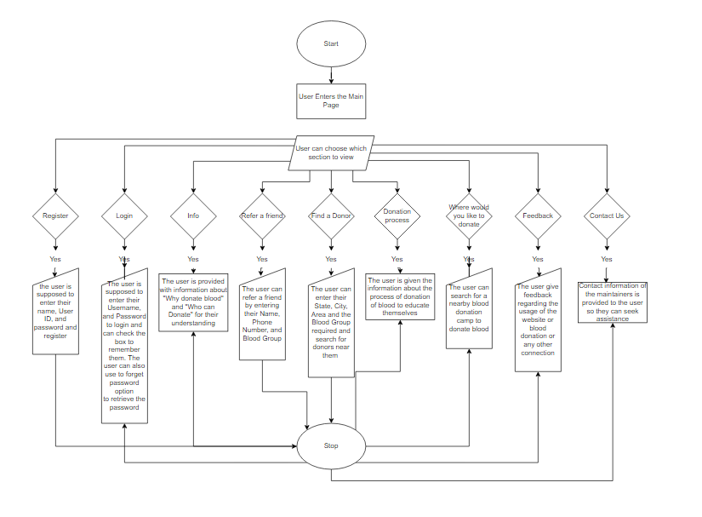 FLOWCHART

IMPLEMENTATIONS

* In the Landing page we have the **Blood-Donation** video to motivate folks to donate blood and create awareness by displaying a very good quote “You are someone’s type, Please Donate.” followed by **Register** button, **Why donate blood button**, **Who can give blood** button, **Refer a friend** button and then **Contact-US** button. We have attached hyperlinks to all these to redirect user to all the five sections which have the required forms to be filled up, adding to that the information regarding the same.
* Just below these buttons we have photo and video gallery for our users to get an idea of Blood-Donation and also to motivate to take a step ahead and a short playable gif to give some value to the user’s.
* Below we have a small section for searching for your suitable and accessible location, where one can donate blood and simultaneously get a slot booked for a particular interval of time. On above it we have added the information about the blood-donation process so to make them aware.

Over-View Gallery

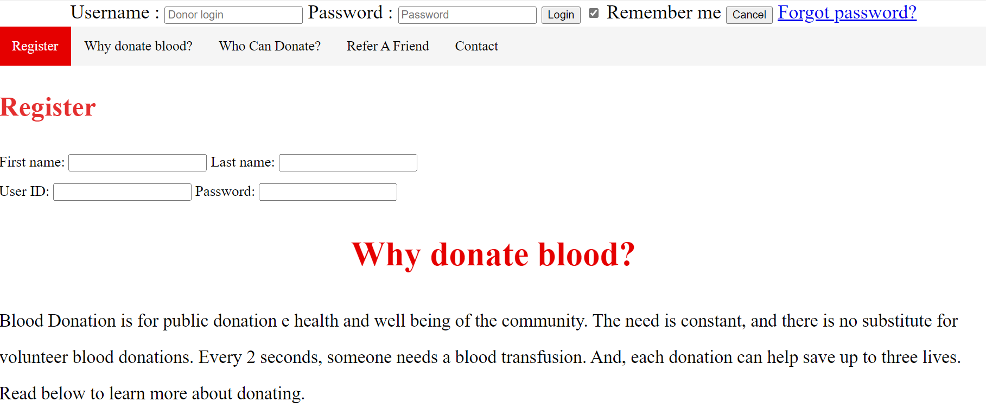

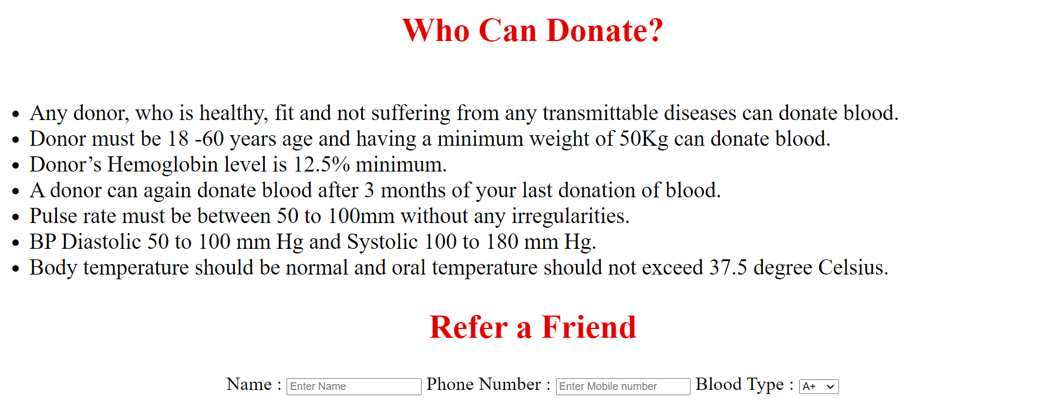  
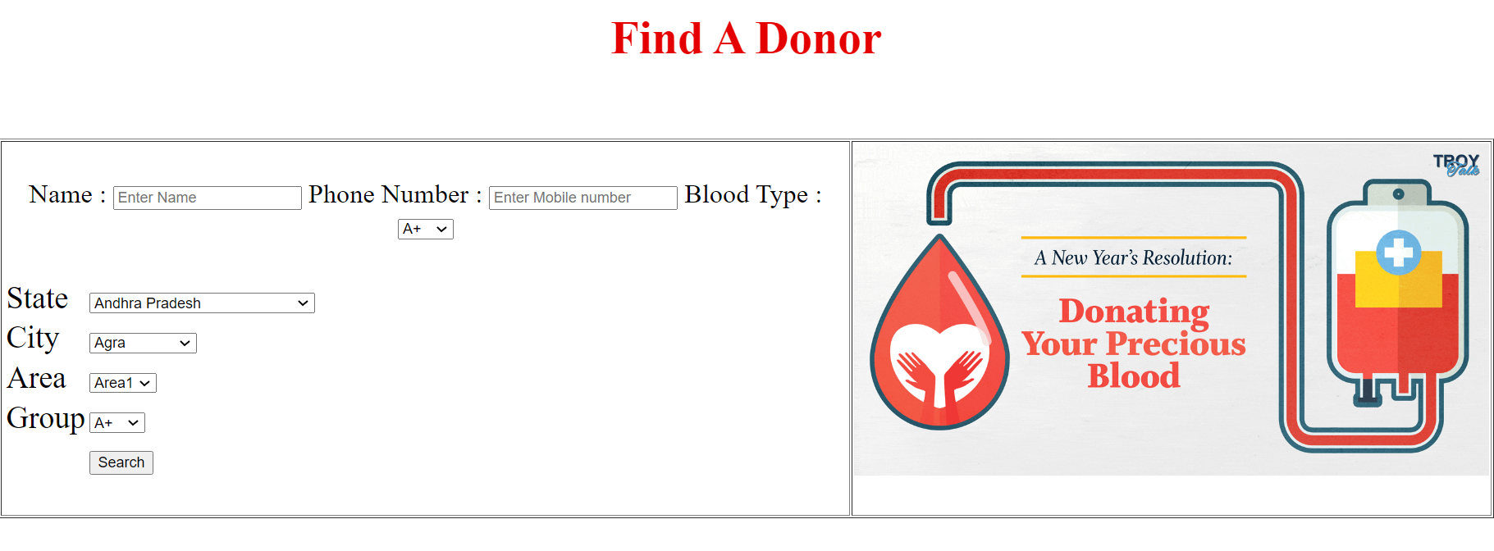

TECHSTACKs USED

* HTML
* CSS
* JavaScript